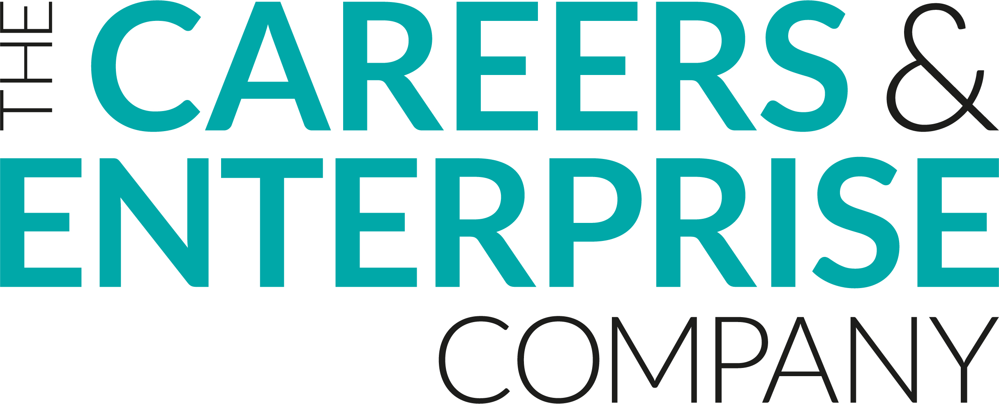
Meaningful Encounter Feedback
Student
Student Name:
Event Title:
Year Group/Key Stage:

Preparation & Intent
I was well prepared for this event and understood the purpose of the event
Strongly agree | Agree | Neither Agree nor Disagree | Disagree | Strongly Disagree
Organisation and Implementation
I enjoyed the event
Strongly agree | Agree | Neither Agree nor Disagree | Disagree | Strongly Disagree
Employers and staff seemed well prepared for this event
Strongly agree | Agree | Neither Agree nor Disagree | Disagree | Strongly Disagree
Impact
This event has helped me to understand careers and the world of work
Strongly agree | Agree | Neither Agree nor Disagree | Disagree | Strongly Disagree
This event has helped me to develop key skills (i.e. listening, presenting, problem solving, creativity, staying positive, aiming high, leadership, teamwork)
Strongly agree | Agree | Neither Agree nor Disagree | Disagree | Strongly Disagree
Please reflect here on what you have learned in this event
What went well about this event?
How could this event be even better?

